**Step 1: Sign in to AWS Management Console**

* Go to the [AWS Management Console](https://aws.amazon.com/console/) and log in with your AWS credentials.

**Step 2: Navigate to EC2 Dashboard**

* In the AWS Management Console, search for **EC2** in the "Find Services" search bar, then click on **EC2** under Services to open the EC2 Dashboard.

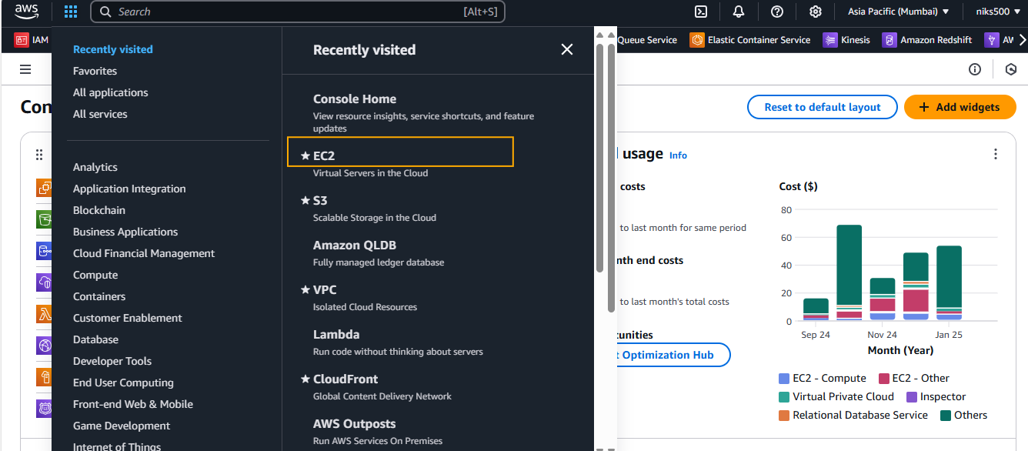

**Step 3: Launch Instance**

* In the EC2 Dashboard, click the **Launch Instance** button to begin the process.

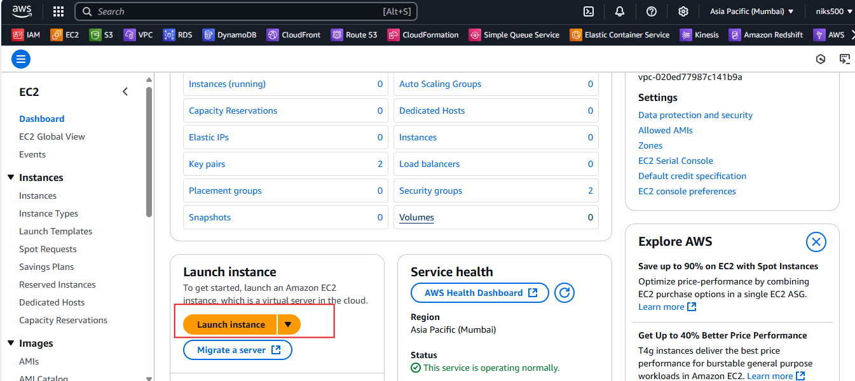

**Step 4: Choose an Amazon Machine Image (AMI)**

* **Select an AMI:** This is the operating system and software configuration for your instance. You can choose from:
  + **Amazon Linux 2**
  + **Ubuntu**
  + **Windows Server**
  + **Custom AMIs**
* Choose the one that fits your needs.

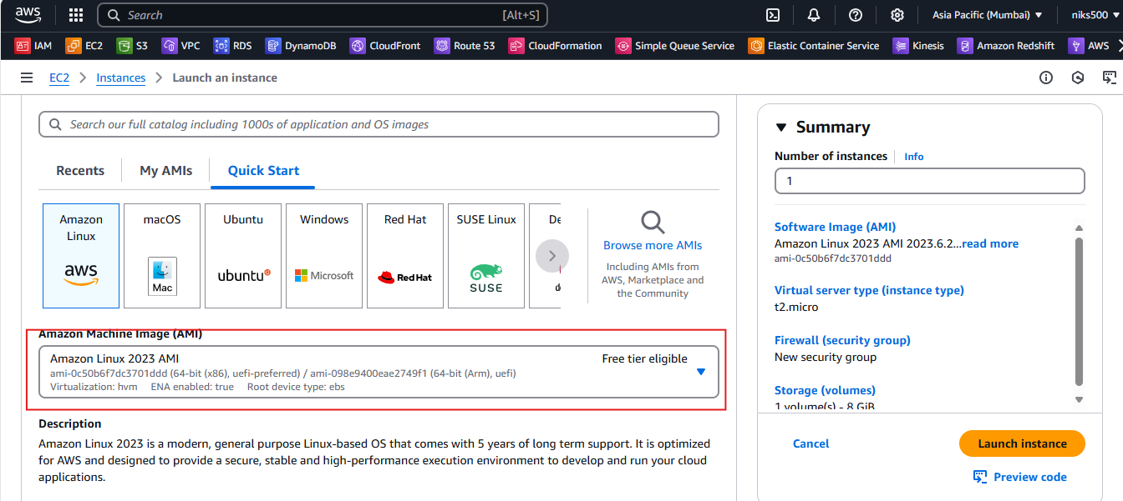

**Step 5: Select an Instance Type**

* **Choose an Instance Type:** AWS offers various instance types with different combinations of CPU, memory, storage, and networking capabilities.
  + For example, **t2.micro** (eligible for the free tier) is commonly used for testing and development.
* Click **Next: Configure Instance Details** after selecting your instance type.

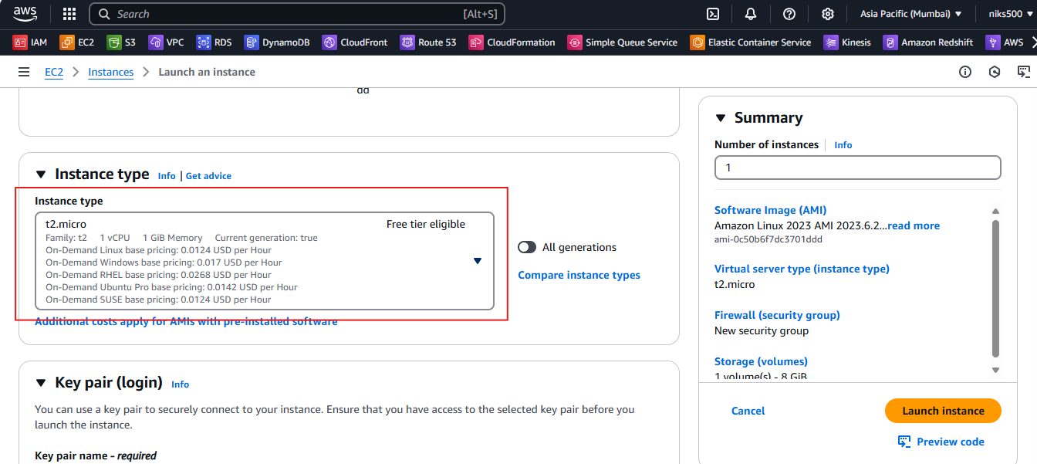

**Step 6: Configure Instance Details**

* **Number of Instances:** Choose how many instances you want to launch.
* **Network:** Select the Virtual Private Cloud (VPC) or use the default.
* **Subnet:** Choose a subnet if necessary.
* Leave other settings as default unless you need specific configurations (e.g., IAM role, monitoring, etc.).

**Step 7: Add Storage**

* **Configure Storage:** By default, an 8 GB EBS (Elastic Block Store) volume is attached, but you can adjust the size and add more volumes if necessary.
* Click **Next: Add Tags**.

**Step 8: Add Tags (Optional)**

* **Tags:** Tags are key-value pairs that help you organize your instances.
* For example, you can add a tag with the key **Name** and value **MyFirstEC2Instance** to easily identify it later.
* Click **Next: Configure Security Group**.

**Step 9: Configure Security Group**

* **Security Group:** Create a new security group or select an existing one.
  + If creating a new one, define rules such as:
    - **SSH (port 22)** for Linux instances (or **RDP (port 3389)** for Windows instances).
    - **HTTP (port 80)** for web servers or **HTTPS (port 443)** if you're hosting a secure site.
  + For security, restrict access to specific IP addresses rather than opening ports to everyone.
* Click **Review and Launch**.

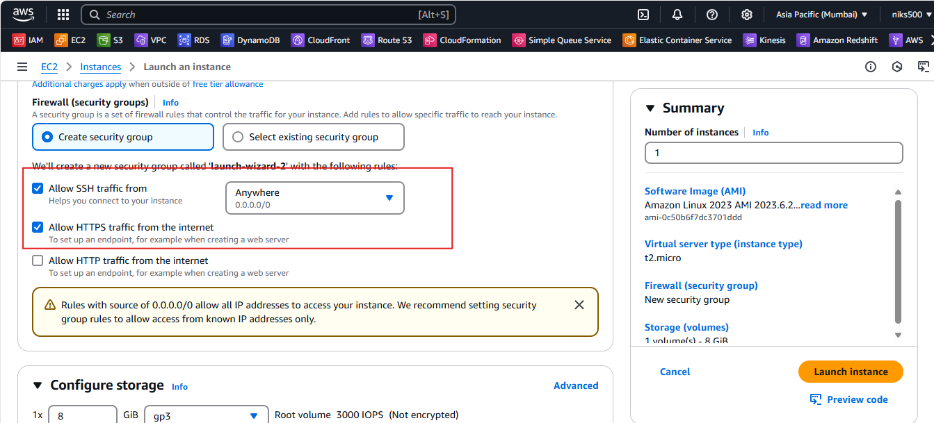

**Step 10: Select Key Pair**

* **Create a new key pair** or select an existing one.
  + **New Key Pair:** Enter a name for your key pair, then download the .pem file (this will be used for SSH access to your instance).
  + **Existing Key Pair:** Select it if you've already created one.

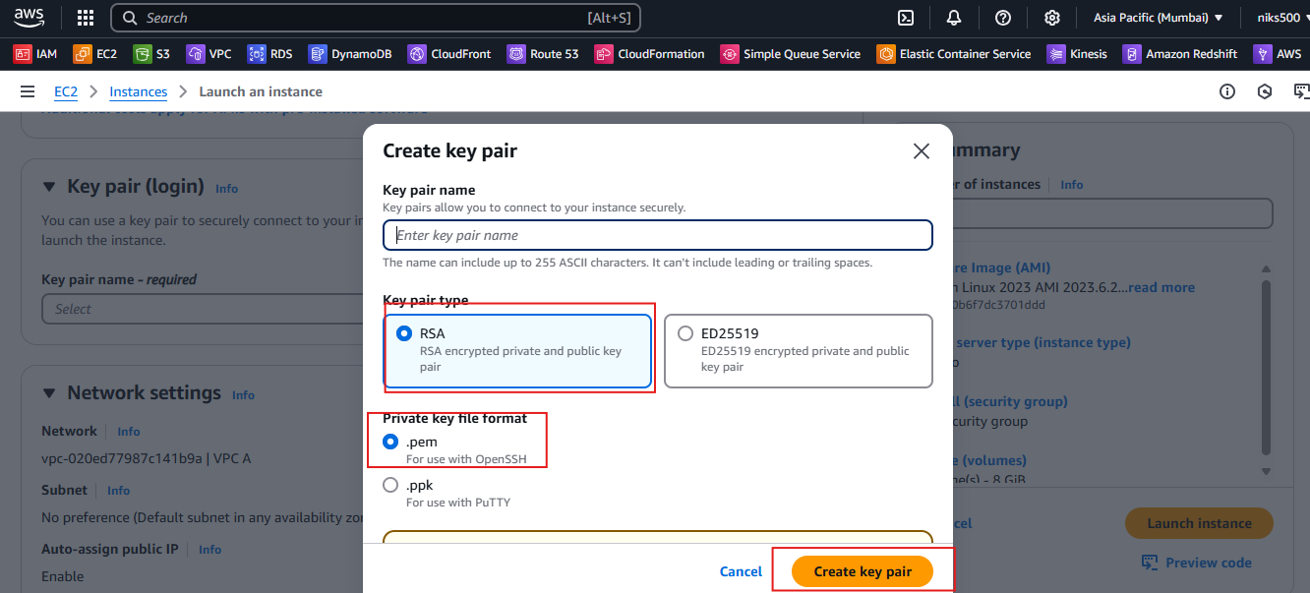

* Confirm that you’ve downloaded the key pair (this is your only chance to do so).

**Step 11: Review and Launch**

* **Review your selections:** Ensure everything is set up as you desire (AMI, instance type, storage, security, etc.).
* Click **Launch**.